TREE Datastructure

1. Basics :
Resources : https://www.youtube.com/watch?v=qH6yxkw0u78
- Tree a non Linear or non sequential Data structure :
- Tree is used to represent hierarchical data. For example – Organizational Hierarchy
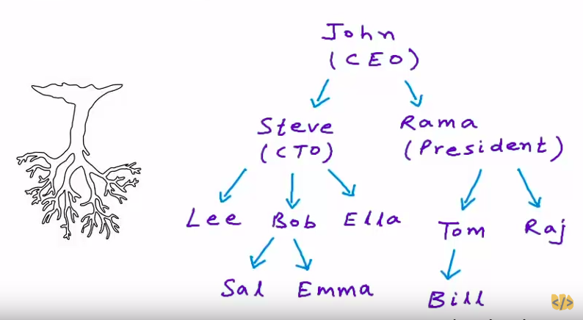
- Logical representation of the tree is like above diagram which shows hierarchy in an organizational structure. It shows root at the top and branches in downward directions.

Applications of Tree:
- To store naturally hierarchical data, for example, file system in our OS.
- Organizing data for quick search, insertion and deletion, for example Binary Search Tree
- Trie Tree is used to store dictionary
- Network Routing algorithms.

Definition:
- Tree data structure can be defined as a collection of entities called nodes that are linked together by edges
- The top most node is root.
- Each node has some kind of data (of any kind).
- Each node may also contain reference or link to its children
- Leaf Node: A node with no child is a leaf node.
- If we can go from Node ‘A’ to Node ‘B’, then ‘A’ is the ancestor of ‘B’ and ‘B’ is the descendent of ‘A’.
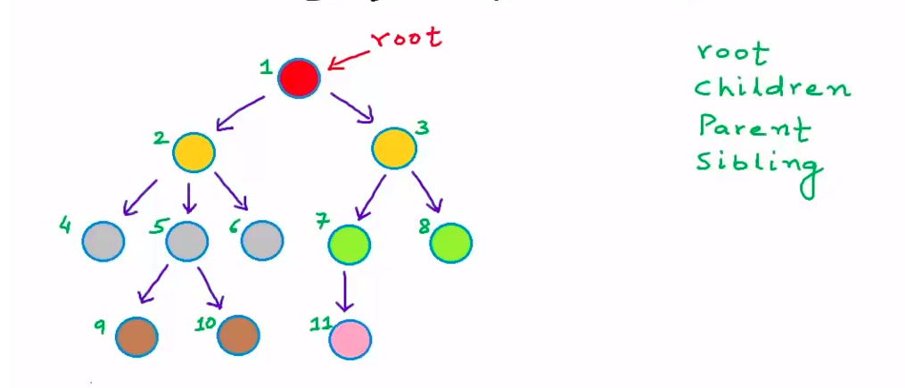

Properties of Tree:
- Tree is a recursive data structure
- In a tree with n nodes, there will be ‘n-1’ edges. (that is one incoming edge for each node except the root)
- Depth: Length of path from ‘root’ to a particular node is the depth of the node. Each edge in the path will contribute one unit to the path. (or No. of edges in the path from root to a node is the depth of that node).
- Height: Height of a node is the number of edges in longest path from that node to a leaf node.
- Height of tree is the height of the root node.
- Height is sometimes calculated as both the number nodes and number of edges.
- With respect to edges -
- Height of a tree with one node is 0
- Height of a tree with no nodes is 1
- Level: All nodes are particular depth are said to be at that level. Max depth of a tree is height of the tree. Maximum number of nodes that we can have a level, say i , is 2 raise to power i
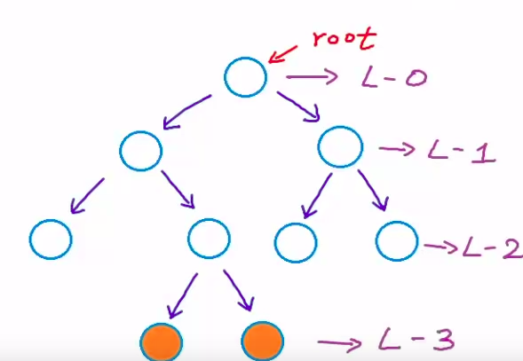

Types of Trees data structure:
a) Binary Tree:
- Tree where each node can have at most 2 child nodes, that is can have 0, 1 or 2 child nodes, not more than that.
- A binary tree is strict binary tree if its has 0 or 2 child.

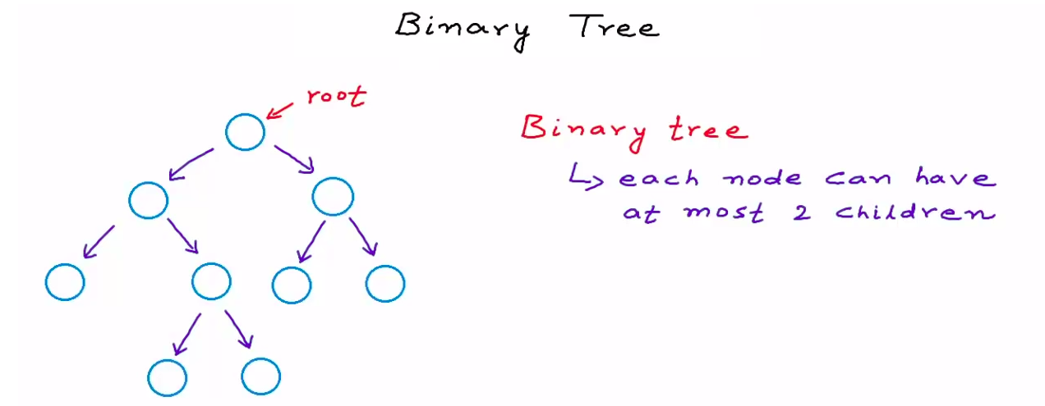

- A binary tree is a complete binary tree if all levels (except the last levels) are completely filled and all nodes are as left as possible.

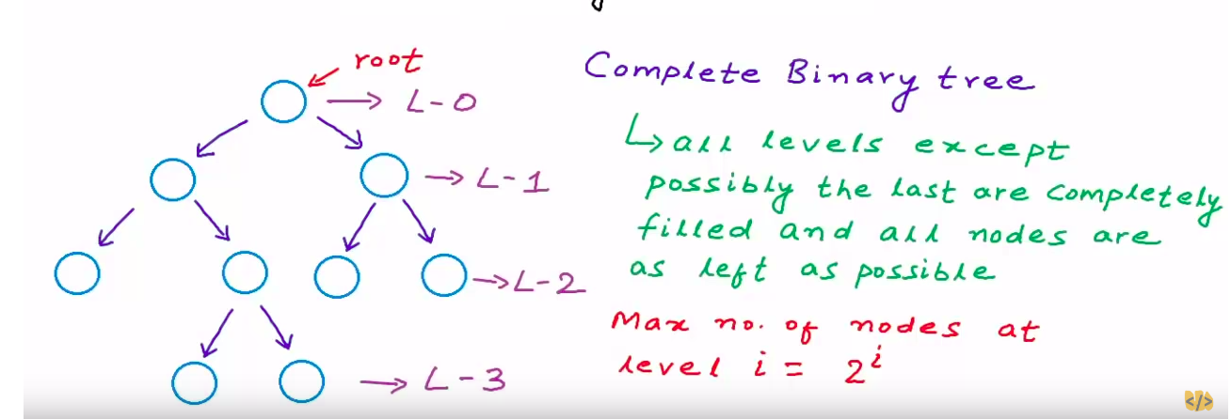

Types of Binary Tree:

1. Proper/Strict Binary Tree:
- Each node should have 0 or 2 children

2. Complete Binary Tree:
- All Levels except the last one are completely filled and all nodes are as left as possible.
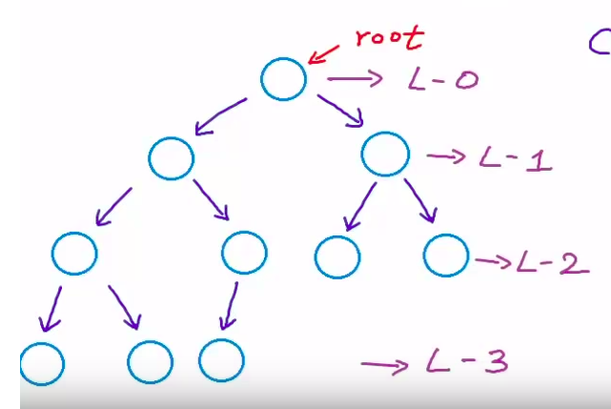

3. Perfect Binary Tree:
- All the levels should be completely filled.
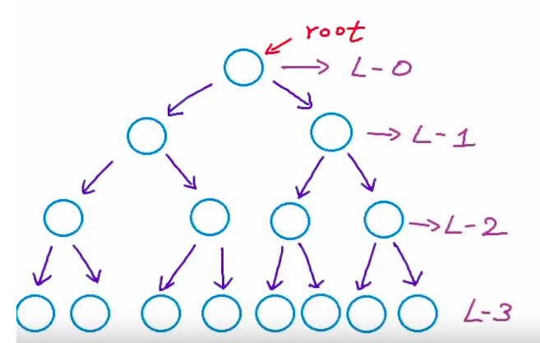

4. Balance Binary Tree:
- difference between the height of left and right subtree for every node is not more than k (mostly 1)

- Maximum number of Nodes in a Tree:
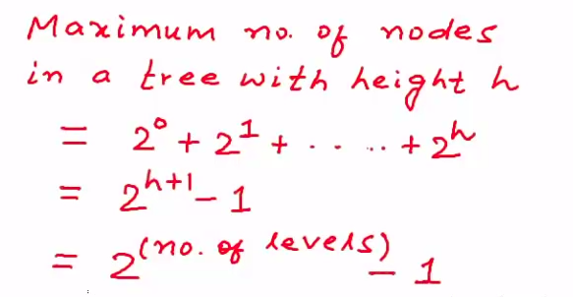

BINARY SEARCH TREE: @11:10

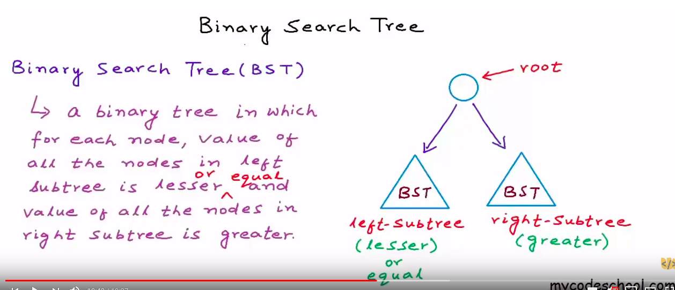
- Efficient for quick search and quick update.
- Search, insert and delete comparisons across Array, Linked List and Sorted Linked List.
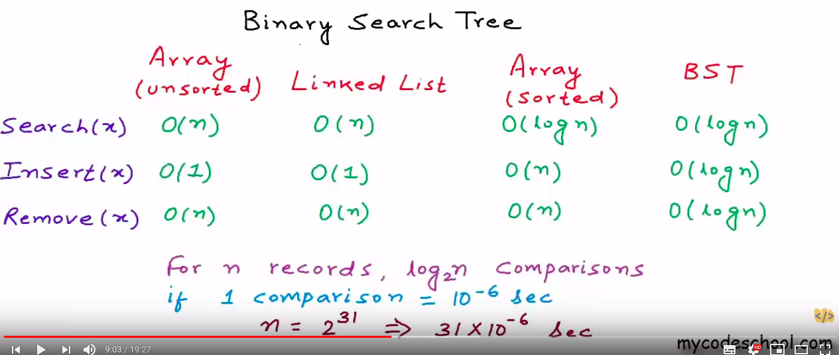

- Cost of operations can be minimized in BST by always keeping it as a balanced Tree.

TREE TRAVERSAL

- There are two basic type of tree traversals:
1. Breadth first Traversal:
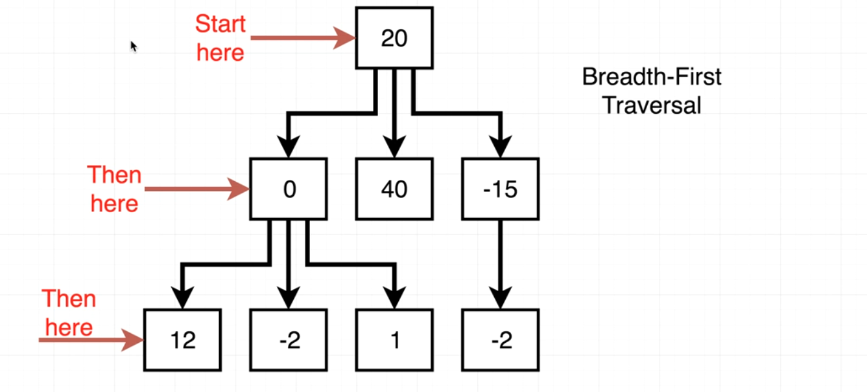
- Going from Left to right at each level

2. Depth First Traversal :
- We start the top (root) and traverse through the extreme left hand side as far as we can go. When we hit the bottom, we go back up to closest parent, then go back down again.
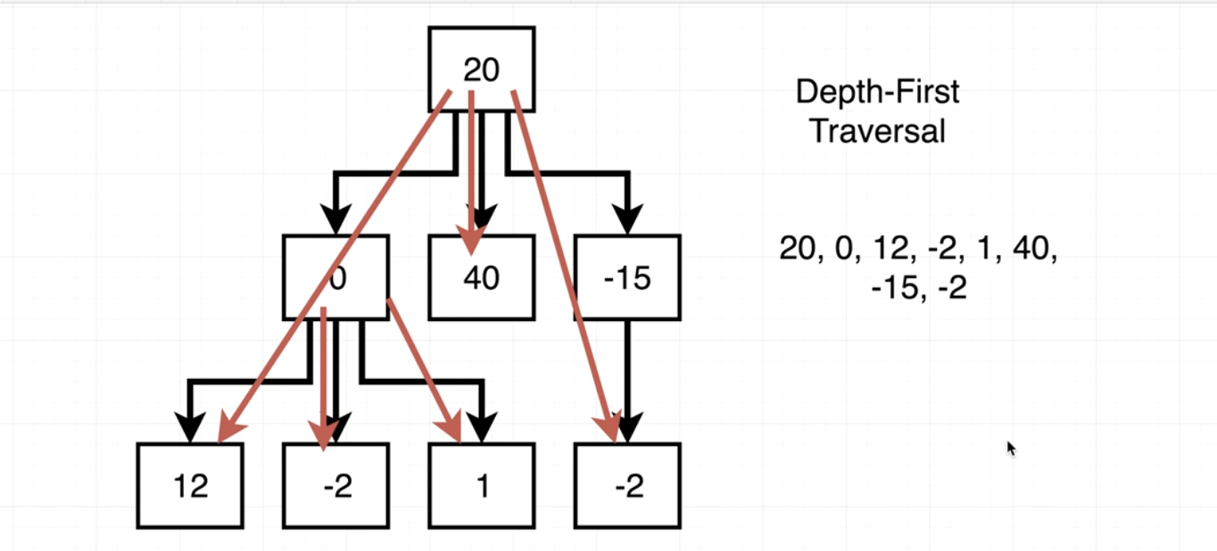

The cost of various operations on a Tree depends upon the height of the Tree. So we would want the height of a Tree to less that is to make it dense or a Complete binary tree.

Binary Search Tree: ((https://www.youtube.com/watch?v=pYT9F8_LFTM&list=) @11:15

A binary tree where:
- Value of all nodes on left subtree is less value of root.
- Value of all the nodes on right subtree must be greater than value at root.
- Both left and right subtree should also be Binary Search Tree.

COMMON QUESTIONS AROUND TREES

1. Tree Traversal

